**DAILY ONLINE ACTIVITIES SUMMARY**

|  |  |  |  |  |  |  |  |  |
| --- | --- | --- | --- | --- | --- | --- | --- | --- |
| **Date:** | **26-5-2020** | | | | | **Name:** | **Likhitha.M** | |
| **Sem & Sec** | **6th sem ‘A’** | | | | | **USN:** | **4al17cs046** | |
| **Online Test Summary** | | | | | | | | |
| **Subject** | | **Computer graphics and visualization** | | | | | | |
| **Max. Marks** | |  | | **Score** | | |  | |
| **Certification Course Summary** | | | | | | | | |
| **Course** | **Python for machine learning** | | | | | | | |
| **Certificate Provider** | | | **Great learning** | | **Duration** | | | **1 week** |
| **Coding Challenges** | | | | | | | | |
| **Problem Statement:**   1. Write a program in c to print all permutations of a given strings of a pointer. 2. This is a Python Program to read a number n and print the number of digits in it 3. This is a Python Program to Check if a Number is a Palindrome | | | | | | | | |
| **Status:completed** | | | | | | | | |
| **Uploaded the report in Github** | | | | | **yes** | | | |
| **If yes Repository name** | | | | | **https://github.com/likhithaMantaral/Daily-status** | | | |
| **Uploaded the report in slack** | | | | | **yes** | | | |

Certification Course Details:

**Numpy:**

numpy is python’s package for doing math that is more advanced than +,-,*, /. This includes special functions like cosine, exponential, sqrt etc. On top of this we can use numpy to generate samples from many types of random variables. numpy also has powerful data type to define vectors, matrices and tensors. On top of this we can use numpy to generate samples from many types of random variables. with these data types numpy also allows us to do linear algebra-matrix multiplication etc. solved some programs.

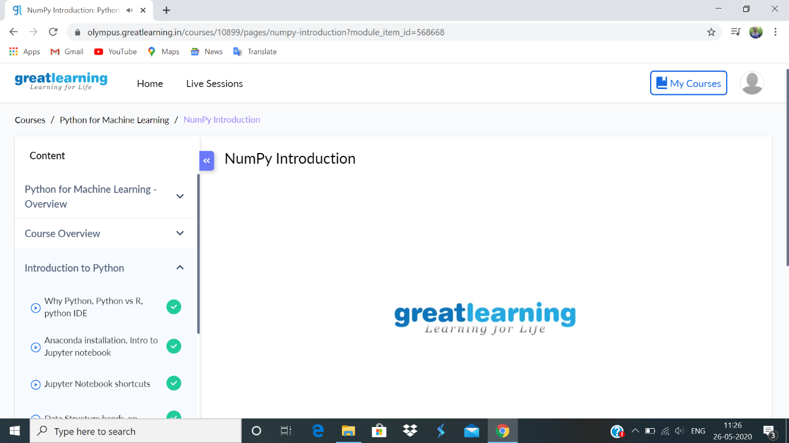

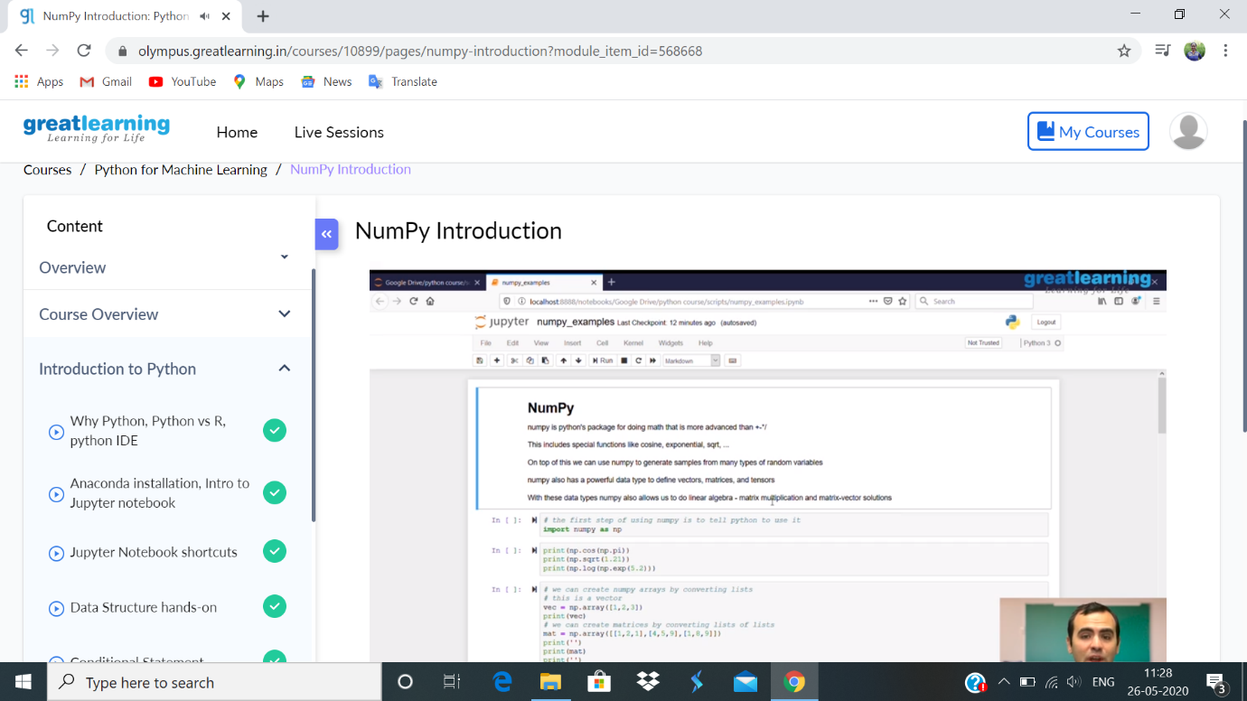

Coding challenges:

1.

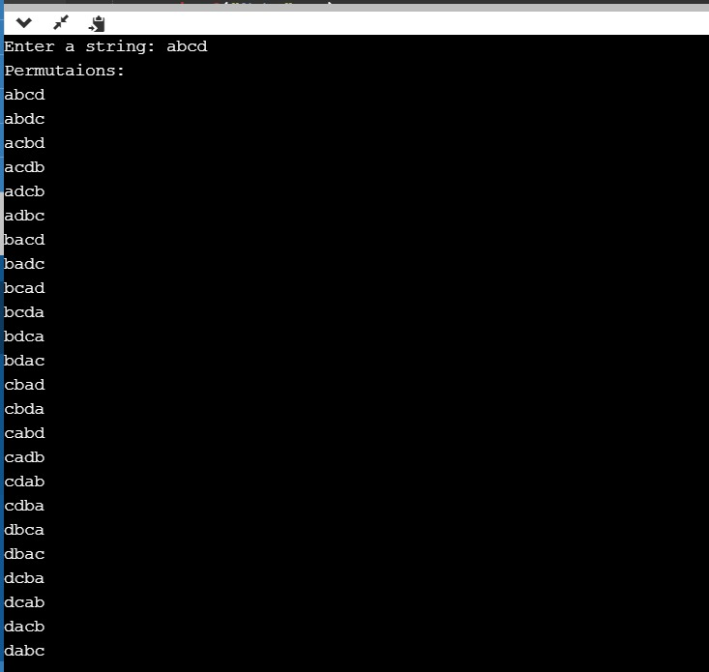

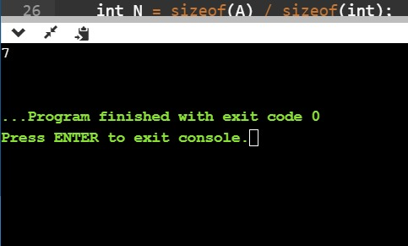

2.

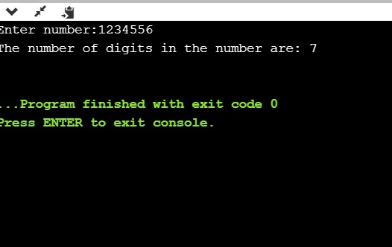

3.

